Power, Controls and Backplane for CU RoboSub

Requirements Specification

October 27, 2016

Ocean’s Seven

Kyle Harlow

Cassandra Noice

Abbigail Caballero

Yuvin Kokuhennadige

Hassan Alahmed

Daniel Henderson

Table of Contents

1. Introduction………………………………………………………………………………...3

1.1 Purpose……………………………………………………………………………..3

1.2 Scope……………………………………………………………………………......3

1.3 Definitions, acronyms, and abbreviations………………………………...3

1.4 References…………………………………………………………………………4

1.5 Overview…………………………………………………………………....….…..4

2. Overall Description……………………………………………………………………....5

2.1 Product perspective……………………………………………………………..5

2.2 Product functions……………………………………………………………….6

2.3 User characteristics……………………………………………………………...7

2.4 Design Constraints………………………………………………………………7

2.5 Assumptions and dependencies……………………………………………..7

3. Specific Requirements…………………………………………………………………..9

4. Use Cases…………………………………………………………………………………...11

4.1 Powering On……………………………………………………………………...11

4.2 Normal Operation……………………………………………………………...11

1 Introduction

* 1. Purpose

In this document we will be outlining how we are going to meet the requirements of our customer CU RoboSub. We will go through the product perspective, product functions, user characteristics, design constraints and specific requirements to make sure that CU RoboSub know we are headed the right direction and our final product will fit their requirements. Since our product is part of a larger product we have to make sure we are working with the correct design constraints so that the final integration of all systems will be possible.

* 1. Scope

The technological environment of science exploration and military operations is leaning more and more towards autonomous vehicles, whether it is on land, in the air, or underwater. From an engineering perspective, Autonomous Underwater Vehicles (AUV) presents unique challenges on many fronts. The environment they operate in is an extremely hazardous one given varying ocean temperatures and currents, significant barometric pressures, numerous flora and fauna capable of immobilizing or incapacitating robotic systems and any sort of long range command systems would require a tether. The systems being developed by Ocean’s Seven are immediately applicable to AUV development and can be extended to improve all forms of autonomous vehicles.

Product development will include a backplane to provide a level of modularity and upgradability that will allow for rapid testing of prototype components and replacement of obsolete or failed parts; a power distribution system to efficiently convert the single DC voltage, provided by the LiPo batteries to the array of required voltages and current capacities; and a control system that will maintain awareness of acceleration, velocity, and position vectors and take input from the CPU in the form of desired velocity vector, then perform the appropriate calculations and motor array manipulation.

* 1. Definitions, Acronyms, Abbreviations

AUV: Autonomous Underwater Vehicle. A type of vehicle designed to operate in an underwater environment without input from a human operator.

Backplane: The main power distribution and communication board designed to be modular to allow for rapid testing and replacement of sub components, including power conversion circuits, controls system boards, etc.

Control Boards: The combined motor and motion controlling modules responsible for accurately orienting the AUV and determining pathing.

DVL: Doppler Velocity Logger. A bottom tracking sonar device that records velocity and relative position based on Doppler shifts in sonar signals reflected from the sea floor.

ESC: Electronic Speed Controller. A motor controller unit that takes in a PWM signal and outputs a three phase analog voltage to manipulate motor velocity.

IMU: Inertial Measurement Unit: A sensor array consisting of an accelerometer, gyroscope, and magnetometer. The sensor provides accurate data on translational acceleration, rotational acceleration, and magnetic field strength.

LiPo: Lithium Polymer batteries, the primary power source for the AUV.

Motor Array: Eight, three phase, brushless DC motors positioned around the axes of the AUV enabling three degrees of translational freedom and three degrees of rotational freedom.

* 1. References

None

* 1. Overview

The following sections outline the specific requirements from the customer pertaining to the needs of provided hardware and informational requirements of the different components.

1. Overall Description

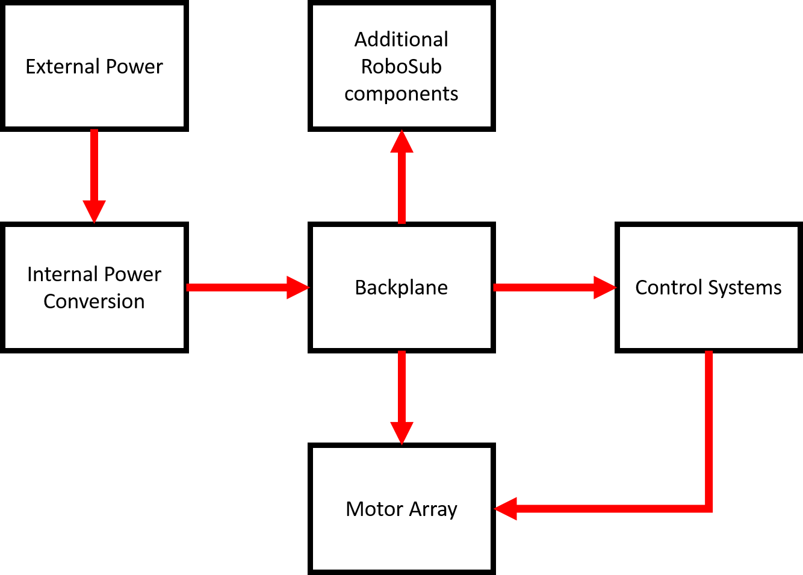

* 1. Product Perspective

The product is divided into three components: the backplane, power system, and the control boards. The backplane unifies power distribution paths and communication buses throughout the AUV, providing simplified integration and upgrading of major components in the AUV.  The power system will consist of multiple buck and or boost circuits to facilitate efficient conversion of the single voltage level DC input from the LiPos to multiple DC voltage and current capacity requirements of the electrical components of the AUV.  The control board is responsible for taking in information from multiple sensors then manipulating the motor array to maintain relative orientation, and take a desired direction and velocity as input then maneuver appropriately to achieve the desired outcome.

* + 1. System Interfaces

A waterproof connection is required to transfer main power from the LiPos to the backplane. The AUV backplane must interface with waterproof connectors in order to facilitate communication and power transfer from within the main hull to external enclosures such as the DVL and the motors. The backplane will interface with additional electrical components outside the scope of this proposal.

Power Systems will interface directly with the backplane and all other devices will draw power from the backplane

The Control Boards must interface with the IMU’s, DVL, ESC’s, and CPU through the backplane in order to sense and change the AUV’s orientation and velocity.

* + 1. User Interfaces

Kill Switch: An externally accessible mechanical switch to disconnect power to all moving parts, including the motor array and any pneumatic devices used for object manipulation.

Location and Orientation Data: Transmitted from the control boards to the CPU via a data bus on the backplane for decision making.

* + 1. Software Interfaces

The AUV controller must interface with the CPU’s mission control software which gives desired orientation and velocity information to the controller.

* 1. Product Functions
     1. Essential Functions
        + User shut down actuator power in hardware (kill-switch) from outside the main hull
        + Power Supply monitors power usage. Unit powers down if abnormal power usage occurs
        + Power Supply distributes stable power to electronic components
        + Controls system keeps unit underwater during operation
        + Controls system allows unit to move in all 6 degrees of freedom so that it can change velocity and orientation as needed.
        + Controls system outputs logs of current orientation
        + Controls system outputs logs of current velocity
        + Controls system outputs logs of estimated position
        + Controls system samples orientation data from IMU’s
        + Controls system samples velocity and position data from DVL
        + Controls system accepts velocity change commands from CPU
        + Controls system accepts orientation change commands from CPU
        + Controls system outputs PWM signals to ESC’s in order to control motors
        + Backplane facilitates power transfer to electronic components
        + Backplane facilitates communication of electronic components via a bus
     2. Desired Functions
* User shut down actuator power in software
* User hot-swaps power switch between batteries and benchtop power supply
* CPU supplies predefined mission functions which the controls system schedules
  + 1. Extension Functions
* Power Supply manages power efficiently for extended run time
* User powers on/off main CPU in hardware from outside the main hull
  1. User Characteristics

|  |  |
| --- | --- |
| Users | Robosub Team |
| Required Knowledge | The user will have explicit knowledge of the system and be able to recreate and debug problems from the documentation |
| Responsibilities | -The user will control software that drives the control system  -The user will be responsible for ensure connection outside of the backplane  -The user will physically install the product into the AUV  -The user will be responsible for charging batteries |
| Success Criteria | The user defines success as having power delivered from the power supply to the electronic components via the backplane, communication with key components via the backplane,  and a well-controlled AUV |
| Disability Accommodation | Installation will not have disability accommodations. Once installed the system should operate autonomously. |
| Language Challenges | Documentation will require knowledge of English. After installation the system should operate independently. |

* 1. Design Constraints
     1. Backplane Constraints
        + Backplane must fit within main hull dimension
          - W <= x.x”
          - L <= x.x”
        + Backplane must interface with waterproof connectors
     2. Control System Constraints
* Control system must interact with a predefined CPU software system provided by the customer
* Control system must interact with ESC’s provided by the customer
* Control system must interact with sensors provided by the customer, or interact with sensors easily acquirable by the customer
  + 1. Power Constraints
* Customer requires power over Ethernet for certain components
  1. Assumptions and Dependencies
* The full interfacing of our design depends on the main hull be completed by the customer.
* Controls system is dependent on sensors that are already given by CU RoboSub and expecting them to be in good working condition.
* Controls system is dependent on CPU input provided by customer.
* Waterproof connectors provided by customer must be properly spliced and arranged in the main hull.
* Controls system is dependent on motor placement which is to be determined based off the main hull design.
* Power requirements are dependent on electronic components provided by customer and subject to change.
* Testing is dependent on access to a large body of water. Typically this will be the CU Rec Center pool which must be open and available.

1. Specific Requirements
   1. Marketing Requirements
2. Accurately maneuver the AUV through the mission
3. Externally actuated mechanical kill switch removing power from moving components
4. Maintain power to all AUV electronics during normal operations.
5. Facilitate communication between electronic components
6. Whole system operation time greater than or equal to 25 minutes
7. Fit within the watertight enclosures on the main chassis without obstructing airflow
8. Include appropriate safety mechanisms (hardware, software) to avoid operating conditions that are unsafe to the system or bystanders

|  |  |  |
| --- | --- | --- |
| Marketing Requirements | Engineering Requirements | Justification |
| 7 | The system must be no wider than x.x (<6)  in., no longer than x.x in. and no taller than x.x in. | The watertight enclosures will be 6” diameter acrylic tubes and all components must fit within. |
| 3,4 | Power traces for all moving components must be isolated from all digital electronics | Activating the kill switch should only disable moving components and not digital. |
| 1 | The system must be able to adjust the vehicle's orientation and velocity to within x.x° and x.x m/s. The AUV must be able to move through designated areas as small as 4’x8’ | The AUV will be travelling over distances up to 100 yards and must arrive at an objective within an observational distance. |
| 4,6 | The system must deliver more than x.xA and y.yV for a minimum of 25 minutes, without replacing batteries | The competition constraints give no more than 25 minutes for running the course. |
| 5 | The system must have a communication bus using xxx standard to facilitate data transfer between electronic components | Multiple components in the AUV will require sending and receiving data.  Implementing a single communication standard reduces the number of data buses required on the backplane. |
| 2,3,8 | The motor power traces must be switchable by means kill switch. | In order to prevent injury all motors must be disabled in the event the kill switch is activated. This must work even when  power to the vehicle is lost. |
| 8 | The power system should shut down if the continuous current draw exceeds x.xA or the LiPo batteries falls below x.xV | LiPo batteries are very dangerous when operated outside of their normal ranges. |

1. Use Cases
   1. UC1: System Initialization
      1. Scope

* The scope for this use case is under normal operations.
  + 1. Level
* The level of this use case is a function.
  + 1. Primary Actor
* The primary actor is the user.
  + 1. Stakeholders/Interests
* *User* – RoboSub team needs to tether in and run the boot sequence after placing it in the pool’s starting area. CPU needs to determine initial conditions to begin operations on specific challenges.
  + 1. Preconditions
* The AUV is positioned in the initial position by the RoboSub team.
  + 1. Main Success Scenario

1. RoboSub team connects the batteries to power on the AUV.
   1. RoboSub team places the AUV in the pool facing towards the starting gate.
   2. RoboSub team connects to the AUV via tethered Ethernet cable and laptop.
   3. CPU undergoes boot sequence.
   4. CPU determines initial position relative to the starting gate.
   5. RoboSub team disconnects tethered cable from the AUV.
   6. AUV powers motors on and move towards starting gate.
      1. Extensions
2. Unable to determine position of starting gate from the initial position.
   1. Restart the system initialization process to make sure the AUV was booted up properly.
   2. UC2: Normal Operation
      1. Scope

* The scope for this use case is under normal operations.
  + 1. Level
* The level of this use case is a function.
  + 1. Primary Actor
* The primary actor is the user.

* + 1. Stakeholders/Interests
* *User –* CPU needs to navigate using the control system.
  + 1. Preconditions
* The AUV has run the system initialization and has oriented itself relative to the starting gate.
  + 1. Main Success Scenario
    2. Control system begins recording data from sensors to determine orientation set current position.
    3. Control system begins accepting commands from CPU in order to manipulate motor array.
    4. Control system adjust PWM outputs on motors to adjust orientation and velocity.
    5. Control system relays current orientation and velocity to CPU.
    6. Extensions

1. Non-recoverable system malfunctions, specifically with regards to motors, causing the run to end
   1. Diver can pull the kill-switch
   2. Enter state UC3

b) Malfunction resulting in high discharge of the batteries,

i) CPU will sense abnormal power consumption and activate the kill switch internally to shut down the power system.

* 1. UC3: Kill Switch Activation
     1. Scope
* The scope for this use case is under normal operations.
  + 1. Level
* The level of this use case is a function.
  + 1. Primary Actor
* The primary actor is the user.

* + 1. Stakeholders/Interests
* *User* – Diver needs to activate kill switch in the case that something happens that isn’t supposed to, or that the AUV is putting either itself or the user at risk.
  + 1. Preconditions
* After primary initialization, the AUV has either had something go wrong or the diver has simply decided to test the kill switch under normal operations.
  + 1. Main Success Scenario

1. Diver notices something unusual has happened.
2. Diver activates kill switch.
3. MCU on power board sends notification to CPU that kill switch has been activated while simultaneously shutting down motors.
4. CPU sends reset sequence to controls board
   * 1. Extensions

None